Planning, Implementation and Organic Management of Agave

Agave (from the greek word αγαυή, meaning ‘noble’ or ‘admirable’) or maguey is a genus of monocots member of the asparagaceae family. The different varieties are very similar in terms of shape and growth. They form a big rosette with strong, freshly leaves located around a stout stem so short that may make the plant appear as though it is stemless. The succulent leaves of most agave species have sharp marginal teeth and an extremely sharp terminal spine. Only a few species have no teeth. Its growth is slow and ends with flowering. Agave rosettes are mostly monocarpic. During flowering, a tall stem or mast grows apically from the center of the rosette. During that same year, it blooms, bears fruit and dies. Throughout the lifetime of many agave species, rhizomatous suckers develop above the roots at the base of the rosette, creating thick colonies which develop and bear fruit.

There are 200 known species of agave and Mexico is home to 150 species, 75 per cent of the world diversity.

The Billion agave project is an innovative strategy that consists of associating trees or shrubs (usually nitrogen fixers) strip-intercropped with annual crops or perennial grasses, where the woody branches are periodically pruned to avoid the shade on the crops, and the pruning residues are used as green manure to improve soil fertility and as high-quality forage.

The project goes beyond reforestation, forage production and soil regeneration. This initiative aims to plant a billion agaves globally to reduce and store billions of tons of CO2 that destabilize the climate.

Getting Ready

A field visit to the area were the plants will be established is very important in order to have a better idea of the land and possible obstacles that may interfere both in designing the planting pattern as well as making any necessary changes and adjustments.

- Soil Test.
During the visit and field trip we take random soil samples with different techniques based on topography and accessibility. The goal is to know the physycal, chemical and biological conditions of the soil to better understand it and make amendments if necessary.

- Getting the soil ready.
Whichever technique we use to get the soil ready must prioritize avoiding soil erosion and favour hydric infiltration as much as possible.

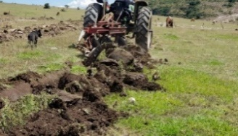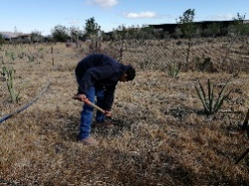

There are different tecniques and/or processes to prepare the soil, amongst the most common are:

- Contour farming- This technique consists of tracing a straight line from the highest point in the plot to the lowest, subsequently a middle point of the line is selected to keep as a reference and start tracing one or more main lines at certain distances which will be defined based on the slope of the terrain and will be drawn using different tools that will indicate a succession of points to follow and mark so that machines can follow a pattern when the work in the field starts. The tools to be used can be either handmade such as tube levels, level A device, etc. Digital tools can be used as well, choosing always tools that are efficient in terms of cost and time and are effective.
It is also recommended to use agricultural chisels of at least 45 cm deep, the depth is based on the orography and the physical characteristics of the terrain.

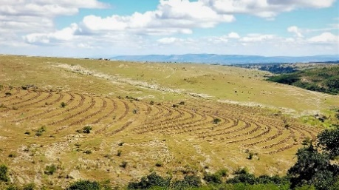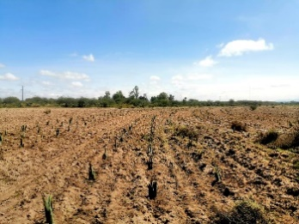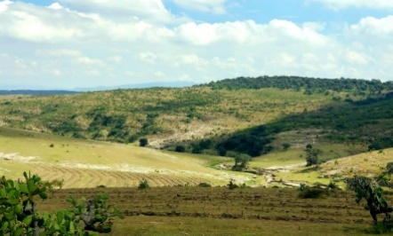

- Simple Straight Line – In the case of plots which do not have a slope or where the slope is 5% or less, it is recommended to use straight lines given that there is no risk of water flows or runoffs that could cause landslides or mudflows. This type of plots can be prepared with agricultural supplies for subsoiling (chisels) in order to loosen soil layers and allow good water infiltration. Soil grinding with discs will also help undo clumps of soil that may interfere with hole digging for planting once the plant is established in the field. For straight line design, it is important to trace and tag the plot, preferably starting from the edges, using stakes, string (raffia) and lime. This guarantees the distance between plants is uniform so that they have the necessary space to develop.
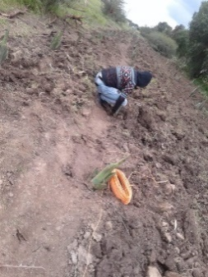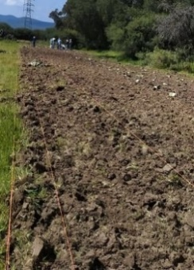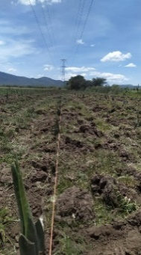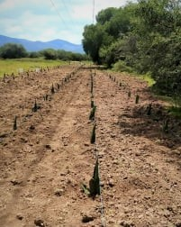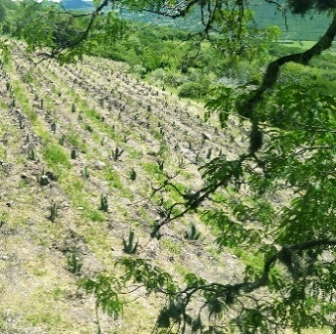

- Keyline Design – This practice uses a special chisel plow that loosens the sub-soil without inverting the soil. The plow also facilitates the transport of organic matter deeper into the soil horizon. The Yeoman plow helps direct water resources from areas in the plot where they are concentrated to areas where humidity is scarce, obtaining a uniform humidity distribution.

If the plot presents an orography with a slope under 15%, a disc harrow should be considered. This is based on the physical characteristics of the soil and taking into consideration the use that has been given to the land before in order to have a wider knowledge and make informed decisions. If the plot has a slope of over 15%, other techniques which do not include total soil remotion should be chosen, in order to avoid landslides and soil erosion. Existing vegetation shouldn’t be disturbed or removed. In case there’s a surplus of trees, those should be relocated in order to be able to access the plot. Those that can’t be relocated should be pruned.
Note: The labor for soil preparation in different plots may be subject to changes given the different characteristics and features of each particular plot.

Planting Pattern.

This is an agave plantation which will be subject to constant maintenance and pruning for use as forage. For this reason, we have chosen a very dense pattern with a population of 1,900 agave plants and 500 mesquite plants for a more efficient use of the land.

The design is the following: Marking four (4) straight lines or curves and from them three (3) will be used to establish agave plants consecutively with a distance of two meters (2m) between them and between rows or lines of agave there will be a distance of a meter and a half (1.5m) On the three lines used for agave, the plants will have to be established in a quincunx pattern to allow for highest plant density (up to 16%) The fourth line will be used for mesquite plants and will be traced one meter (1m) away from the third agave line and the distance between mesquite plants will be of two meters and a half (2.5 m) After the first four (4) lines have been traced, there should be three meters (3m) left free to be used as alleys for monitoring, harvesting and different tasks. After the first three free meters, once again the four lines where the plants will be established should be mark and so on until the total surface of the plot is covered.

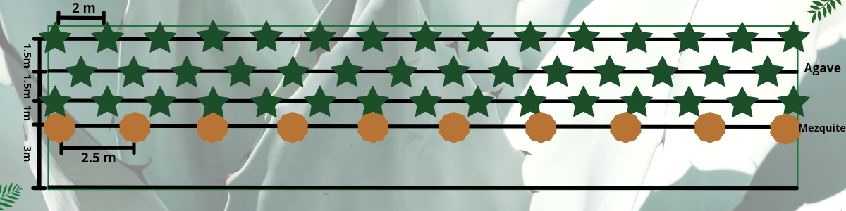

Note: Design and tracing of strategic and logistical accesses from the different plots are of utmost importance because the efficiency for harvesting and other labor will derive from it. The accessibility pattern according to the plantation design will be replicated in each plot. This pattern is subject to changes depending on the different topography of each lot.

Plant Management and Treatment before Planting.

The young agave plant, also known as shoot, sucker, runner or “mecuate” must have a management pre planting plan with the goal to ensure the plant will be in optimal condition and to guarantee an adequate development. There are variations in the preparation of the shoot depending on the geographical area where the treatment is performed and the agave species as well as its use. Prior to the management plan, there should be field visits planned to the plantations that are selected to acquire plants in order to assess health conditions and determine if they are fit to supply plants. In the case of agaves, when the goal is to extract aguamiel (Agave salmiana var. salmiana, Agave salmiana var. crassispina, Agave americana and Agave mapisaga) the following plan management is proposed:

- Plant Extraction.
Should be performed during spring so that the wound in the mother plant isn’t at risk of infection from any soil pathogen and represents a risk.

- Extraction is performed by inserting a crowbar with a flat end to the soil approximately 5-10 cms. from the base of the runner at an angle of about 45° in order to cut the root (rhizome) that unites the runner with the parent plant leaving enough space to make the maneuver without damaging the root of either plant.

Extraction should be performed with a very sharp crow bar – such as the one pictured below- so that the root system isn’t damaged:

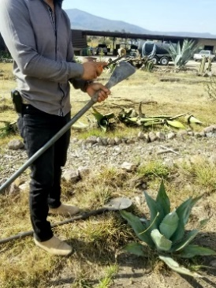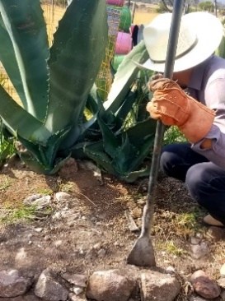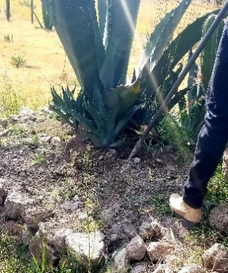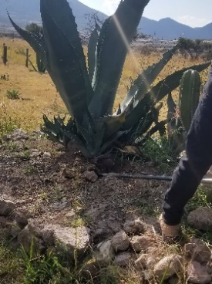

Leaves Pruning (Barbeo)
- Once the runner has been extracted, the next task is to identify damaged leaves or those in poor conditions. They will be removed with a machete or knife sharp enough to do clean cuts. Leaves are very fibrous and so the cut has to be very clean, particularly during springtime when the leaves have less water content. This is done to be able to spot possible pests that spend part of their life cycle living inside the leaves and also to simplify plant handling.
The desirable average amount of leaves for each plant is six. In case the runner has a large amount of damaged leaves, they should be removed ideally keeping three leaves.

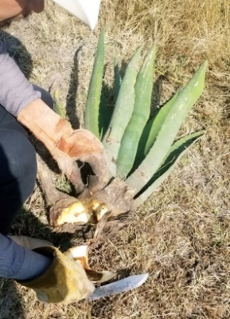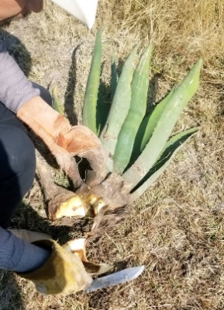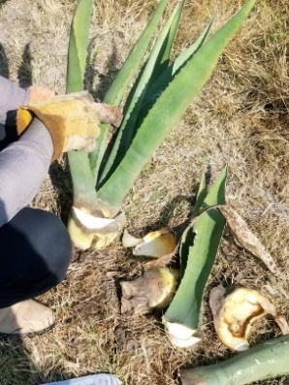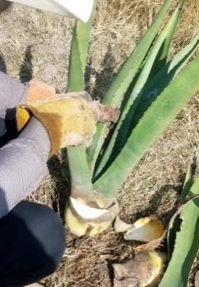

- Root Prunning (Tostoneo).
For root prunning it is esential to consider the humiity of the soil in which the plant will be established. If the soil has similar humidity to the one in the field, the taproot will not be removed from the shoot because it will find the perfect conditions to grow once planted. If the soil is dry, the root will have to be removed almost entirely by performing a transverse cut at the taproot leaving about two to three centimeters long next to the heart (piña). The cut has to be done with caution, if the root is completely cut off then the plant won’t be able to create new runners. One of the goals of root pruning it to assess the runners’health. The root is an entry point for different diseases caused by fungi and bacteria and is also home for certain instars of growth and development of a number of insects.

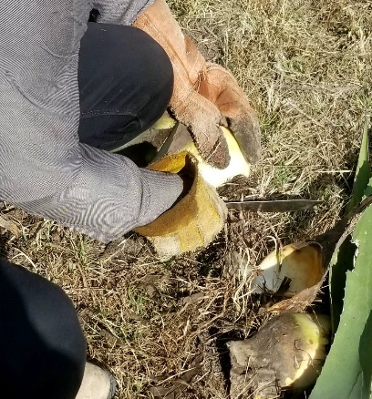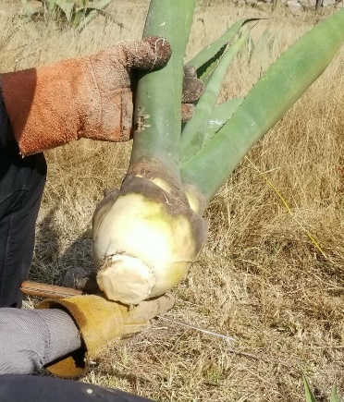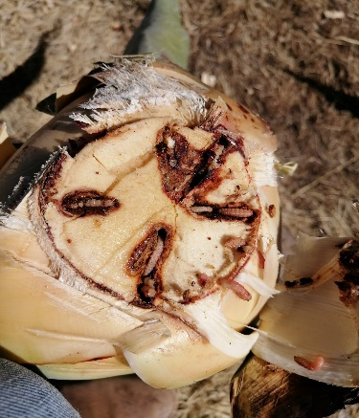

- Plant Disinfection.
Once the process described above is done and the plant is in optimal condition, it will be disinfected to ensure that it is free of internal and external pathogens. The disinfection will be done by immersing the plant in a solution made of minerals such as Cal + Sulfur (sulphate and calcium products) or Cal + Copper Sulphate (Bordeaux Mixture) and storing them in a shadowy area with good air flow in order to give the plant enough time to heal whatever wounds it may have from the preparation work.

Planting.
Once the soil and plants have been treated, it is time to plant them so they can start developing. The tracing of lines or curves will be done according to the pattern established for the plot, holes will be dug with a depth of about 20 cm3 in which the agave plant will be placed and will be covered with dirt up to three quarters of the heart. Soil at the base should be compacted and the same procedure should be applied to the mesquite plants except the holes should have a depth of 40 cm3. Different areas for plant incoulation should be set up.

Treatment: Immersion in a liquid solution consisting of fungi bio fungicide (Trichoderma sp) and enthomopathogenic (Beauveria bassiana sp, Metarhizum spp,) to provide the plant organisms to increase its survival rate. It is also advisable to apply an amount of certain beneficial fungi (mycorrhizae) and a compost made of compost, vermicompost, Johnsonn-Su etc. directly inside the hole where the plant will be placed.

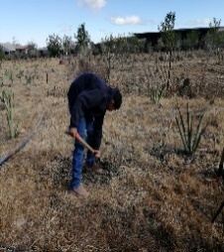 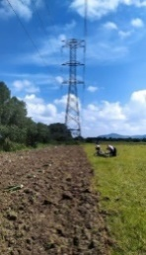 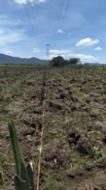 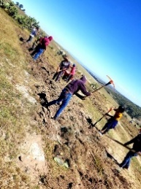 .

Supplies for plant treatment:
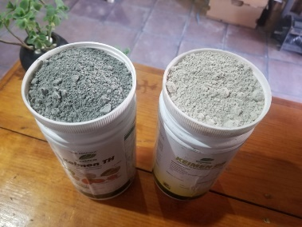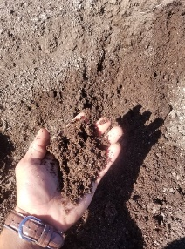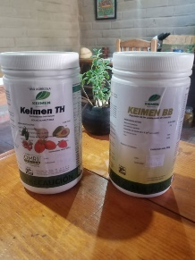

Integrated Pest Management (IPM)

A pest is a living organism which interferes or directly affects the development at any given stage of an individual or a population, whether vegetal, animal, fungi, etc. Pest Management comprises diverse contol methods used for pest and disease monitoring and control that represent a risk for the plants health. Vía Orgánica uses mechanical/manual, biological and ethological control methods, with no use of chemical products. Field trips must be done at the places where the plants have been set up in order to observe and identify the presence and population size of the organisms that may risk the health and development of the plants and design and plan preemptive controls to avoid the growth of those populations. Different pests and diseases are caused by diverse biological agents which affect agaves and may be prevented and controlled with products that don’t damage the environment, such as:

- Entomopathogenic fungi ((Beauveria spp, Metarhizium spp, Lecanicillium leccanii spp, *Trichoderma spp, etc.)
- Mineral base solutions (Bordeaux Mixture, Sulphucarcialum, ashes, etc.)
- Bioinsecticides with a vegetal extract base (Quillaja Saponaria, Azadirachta indica-Neem,etc.)
- Beneficial bacteria (Bacillus spp, Pseudomonas spp, etc.)

Setting up Pheromone traps:
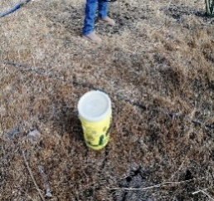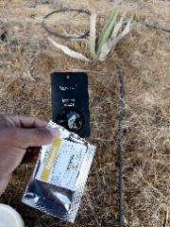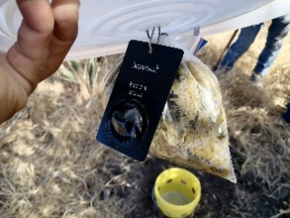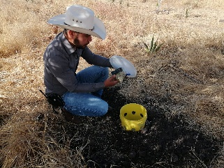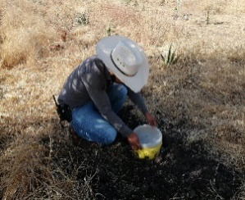

Entomopathogenic fungus and biofungicides:

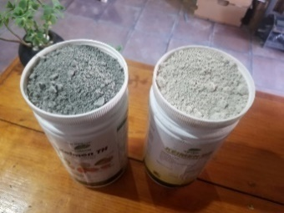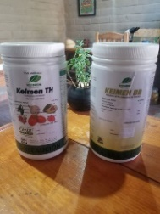

Main Agave pests:
- Scyphophorus acupunctatus (picudo del maguey)
- Oryctes nasicornis (escarabajo rinoceronte o toro)
- Acanthoderes funeraria (escarabajo funerario)
- Melanoplus sp, Sphenarium sp, Brachystola sp. (chapulín)
- Acutapsis agavis (escama armada)

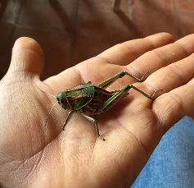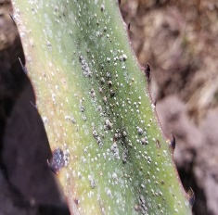

Nutrition.

Agave nutrition during its life cycle is one of the most important practices to take into consideration. If done well, the plant will be provided with the nutrients it needs to grow and develop and will present better defense conditions facing pathogenic agents that risk its health and that of the plantation. It is important to make a step-by-step nutrition plan annually based on natural products that won’t damage and/or affect the environment, flora and fauna, soils, workers, etc. These are some of the inputs to consider:

- Vermicompost.
- Conventional Compost.
- Johnson-Su Compost.
- Diatomaceus Earth.
- Diverse Minerals.
- Fermented Compost such as Bokashi.

Note: The abovementioned inputs and others to be considered could be applied edaphic (soil) or foliar (leaves) they could also be applied in a liquid or solid state, depending on some factors that may affect its application such as: environmental conditions (wind, solar radiation, humidity, etc.) , agricultural equipment, schedule, crew, etc.
*Dosage may vary depending on the phenological stages or plant age.

Pruning for agave health and maintenance.

Agaves, just like most crops, require attention and maintenance during its life cycle with the goal to ensure an ideal crop.
Agaves need maintenance prunes that consist in the removal of leaves and base leaves with the goal to obtain raw material for the process of elaboration of silage that Vía Orgánica processes for the Billion Agaves project. In turn, such prunes also provide the plant with the health they need by having a control of the orientation in which they grow and the total area of the plant to avoid invasion and competence with other plants around them.
Vía Orgánica proposes yearly prunes after the second year of setting up the plantation with a leaf removal percentage of 15-20% of the total and successively will be made during the entire life cycle of the plant.
The first year after setting up the plantation, a field inspection will be made with the goal to determine if the plantation is suitable, or it requires pruning.
Vía Orgánica proposes prunes to be programmed and executed during springtime -months of March to June. During this period is when the plant holds less liquid (sage) in their leaves, and therefore solids are more concentrated, making it an ideal time for pruning. Other times of the year pruning can also be performed but the period just mentioned is ideal.
To perform this work we suggest the use of long handle tools with a round and/or curve blades with a sharp edge. You can also use tools with a short handle with a sharp blade or serrated end such as: Machete, hand saw, blade, etc.

Efficient tools for agave pruning:

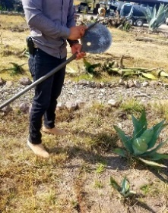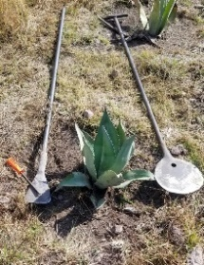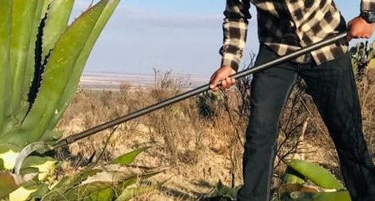

Agave pruning:

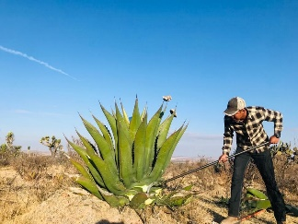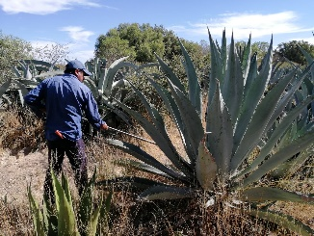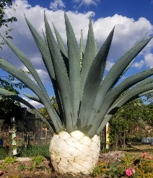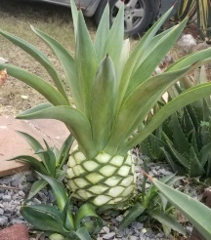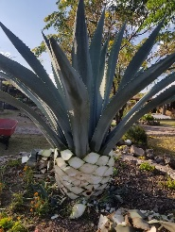

Note: The amount of leaves to be removed for each plant varies depending on the original amount they have. It is hard to estimate an exact amount of leaves to be pruned.

Extraction and Propagation.

This activity will be performed using the same extraction technique described above which details the correct procedure to extract the shoots from the parent plant with the multipurpose goal of obtaining raw material for future plantations and at the same time avoid nutrient and space competition in certain spaces. It is recommended that the extraction is made during springtime, preferably during the month of May so that both plants have enough time to heal the wounds made by the cuts before the rainy season (summer), that way avoiding possible infections by pathogens in the soil.

* Extraction is performed by inserting a crowbar with a flat end to the soil of approximately 5-10 cms. from the base of the runner at an angle of about 45° in order to cut the root (rhizome) that unites the runner with the mother plant leaving enough space to make the maneuver without damaging the root of either plant.

Agaves can be reproduced in sexual and asexual mode, each mode has its advantages and disadvantages and it’s up to the farmer to pick one or use both at the same time which is the ideal in agave plantations.

- Sexual Reproduction: as with most plans, sexual reproduction is the mode of reproduction by the use and sprouting of seeds that agave produces by the end of their life cycle, formed by male and female genes. The advantage of this type of reproduction is that by having both genes, the plant acquires the features from the father and the mother, which provides them with a genetic diversity and therefore more resistance and/or survival rate when facing harsh environmental conditions, pests and diseases. The disadvantage is that the time it takes for the plant to reach its sexual maturity is approximately 10 years.

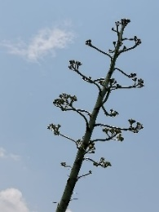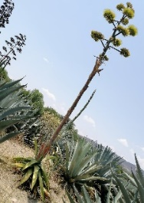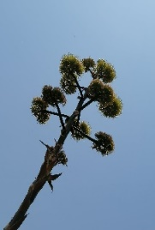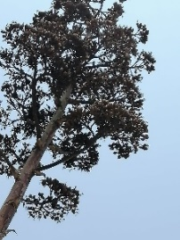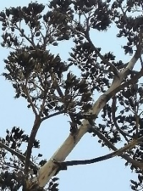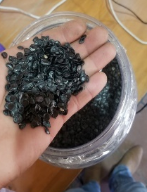

- Asexual Reproduction: This mode of reproduction doesn’t necessarily need female and male genes. Since the plant is monocarpic (blooms once in their lifetime) and requires about 10 years to reach its sexual maturity, it has evolved to develop another way to perpetuate their species. The most common mode is by ground-level basal shoots and rhizomes. This is a faster method but the disadvantage is that it doesn’t carry the male and female genes that will make the plant more resistant to harsh environmental conditions and pests, thus making it more propense to lesser its survival rate.

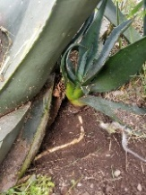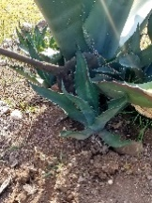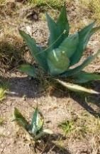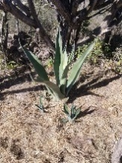

- Agave can also be reproduced by bulbs, short stems with fleshy leaves or leaf bases that function as food storage organs during dormancy.

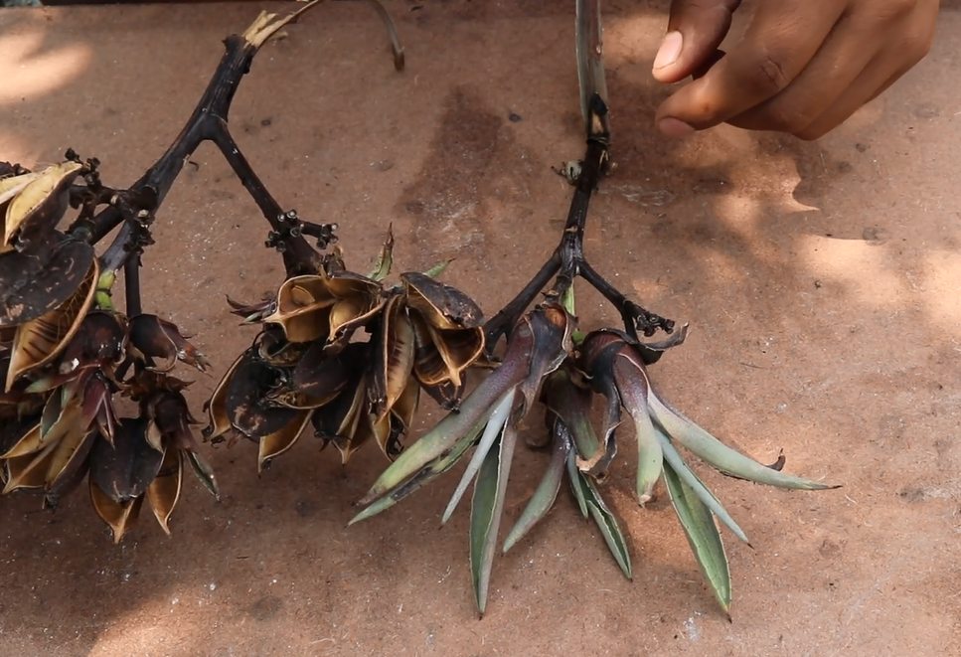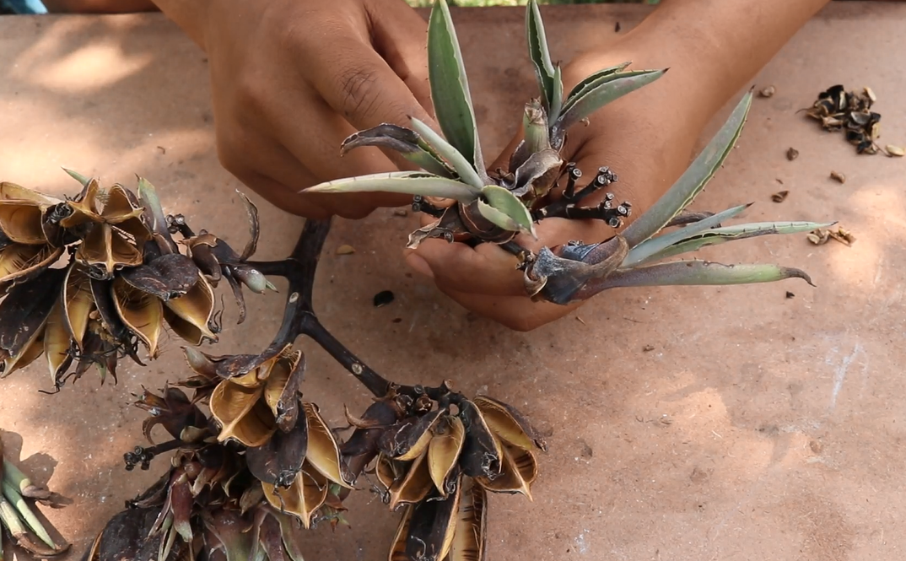

- Vegetative Propagation, a technique used to multiply or replicate certain plants through cells, tissue or organs with the goal to create a clone of the parent plant. This technique provides new plants the environmental and nutritional conditions ideal for their development.

- This is an ideal way to obtain large amounts of healthy plants for setting up a pest and disease free population that will boost the survival rate.

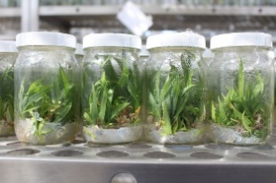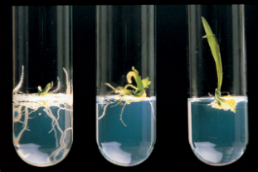

Note: It is important to have a discussion on which is the most suitable propagation mode to obtain the amount of plants needed for each project taking into consideration diverse factors such as financial resources, logistics, contacts, etc.

Complete leaves pruning, heart harvest and seed harvest.

This is the last activity to perform during the life cycle of the agave plants. Based on the age of the plants -that goes from eight to twelve-, bromatological analysis and field observations we will be able to determine which plants have reached or are about to reach the end of its life cycle and are ready to be used.
The name of the activity is jima and it consists of pruning leaves, stem and root leaving the heart of the plant intact. The cuts must be made as close as possible to the base, the tools to use will be the same that were used during the yearly pruning. Depending on the size of the plant, the activity may be done with machines to make it more cost efficient. From the total amount of plants that were established (100%) it is mandatory to leave 5% to bloom in order to save seeds that will be later used for future planting and ensure genetic diversity and also allow plants to complete its life cycle, benefiting biodiversity and optimal development.

